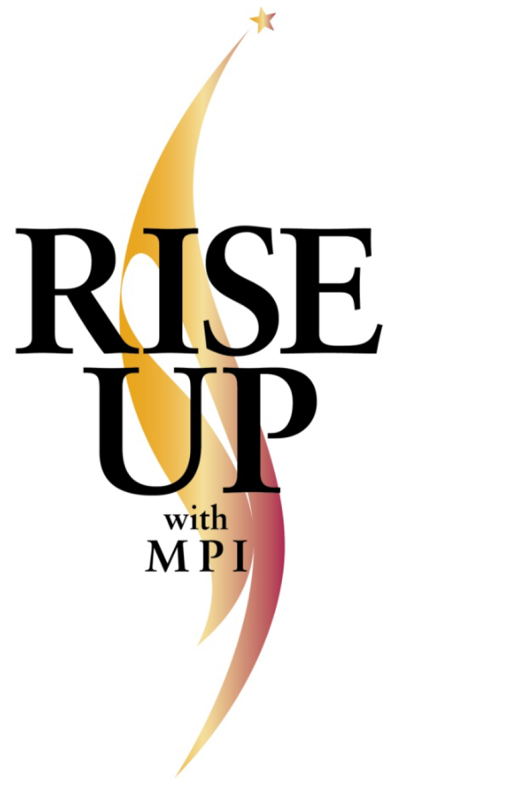
Program Overview &
Frequently Asked Questions

PROGRAM OVERVIEW

What are the RISE Awards?
Meeting Professionals International (MPI) launched the Recognize Industry Success and Excellence (RISE) Award Program in 2009. This annual program recognizes up to four chapters and three individual members from the MPI community based on their work’s influence, transferability, and innovation within the MPI Community and/or the industry at large.

What is the RISE Up initiative?

The RISE Up initiative seeks to operationalize best practices of previous educational RISE Awards nominees or recipients across the MPI Community. Best practices are documented and presented to chapter leadership for easy implementation into chapter planning.

Why should my chapter implement a RISE UP program?

RISE UP programs are identified as best practices. By implementing these proven programs, chapters may benefit from increased membership, a larger number of engaged members and increased chapter satisfaction.

How do we implement a RISE UP program in our chapter?

It is simple! Everything that you need to implement the award-winning ideas are contained in the documentation provided under the RISE Awards tile on the CLRP. Simply download the program of your choice and follow the guidance contained therein to replicate the program in your chapter!

