Preferred Provider Program
For Providers
Uploading Attendee Rosters
- Log in into your portal account at https://myaccount.conventionindustry.org/Login.aspx?ReturnUrl=%2f (There is one administrator per organization)
- On the Home page lower right hand side, click the Upload Roster Icon
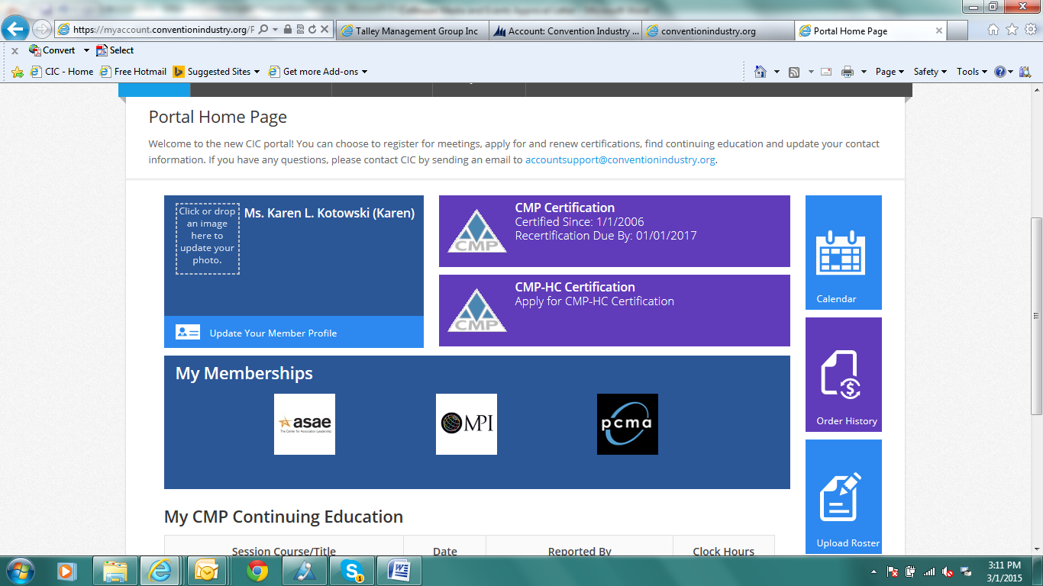
- To submit event attendee information and create CMP Preferred Provider CE records, please follow these steps:
- Select the name of the approved program from the Class drop-down list
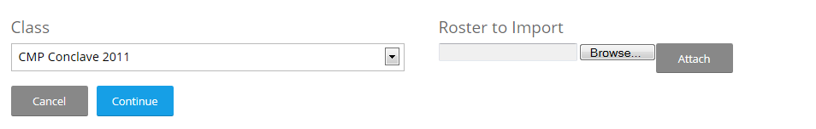
- Click "Choose File", select the appropriate attendee file and click "Ok", then click "Attach".
- If you attach the wrong file you may click "Remove" to remove the file and replace it with another.
- Click "Continue"
  - File Format Requirements
- CSV or TXT format
- One single column with a header row labeled "Email"
- One email address per row
- No other data fields
Please note that only email addresses for verified attendee may be submitted.

The upload will be validated and you will be given a Roster Import Summary

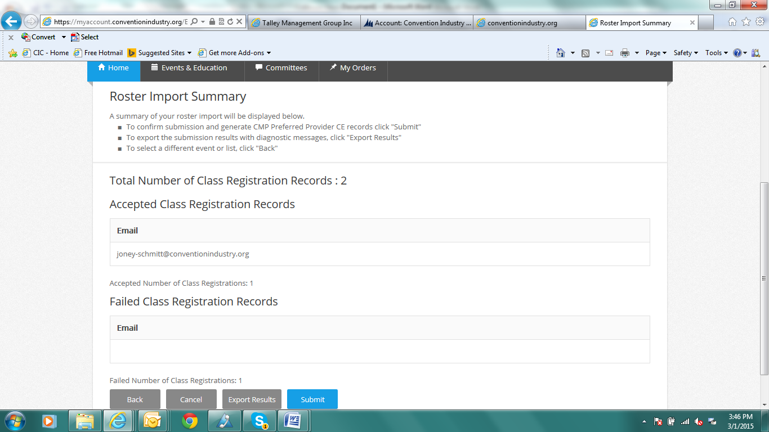

You can then Export the Results – This will give you only the failed email addresses and general reason.
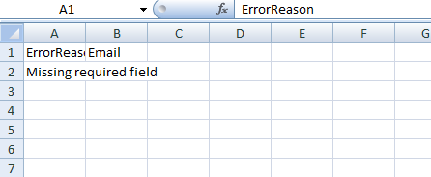

- Click Submit to complete upload

