CHAPTER BOARD SLATE DISTRIBUTION INSTRUCTIONS

In an effort to streamline the annual Chapter board slate submission process for accuracy and convenience, we encourage Chapters to utilize the following 2-step process for board slate submission.
The process includes 2 documents (templates) to be completed by all MPI Chapters for annual board slate distribution.

- Document 1 – Chapter Board Slate for Membership Distribution – this “word document” is for membership distribution and identifies the slate of officers and board members approved by the Chapter’s Board of Directors. They are identified in this communication so Chapter members can view the full board slate proposed for the upcoming term. This document (or template) protects personal identity as it does not include personal contact information. This form should be shared with Chapter members by June 30th annually to allow 30 days for membership review/contest per the Chapter Policy Manual.

- Document 2 – Chapter Board Slate for Internal Distribution – this (excel document) automatically uploads your board slate to the MPI Global’s enterprise member management platform. This automatic upload minimizes the opportunity for errors and omissions. This document (or template) should be completed and submitted to MPI Global by August 1st annually.

Instructions for completion of both these forms are outlined in the following pages.

Please follow the step-by-step instructions on the following pages…

STEP 1

Complete document 1: Chapter Board Slate for Membership Distribution

- Locate and open toolkit located in the CLRP: Chapter Board Slate Submission Toolkit This toolkit is saved in the CLRP > Chapter Administrators > Templates > Chapter Board Slate Submission Toolkit (zip file)

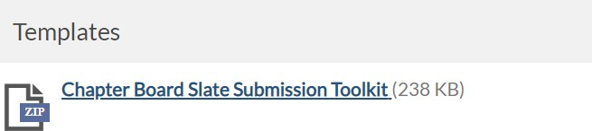

- The zip file will download / Click to open the zip file

Click “Chapter Slate Distribution Templates”

- Click “Chapter Slate for Membership Distribution”

- The document will open. Complete the template with your new slate of Officers and Directors.

- “SAVE AS” name your document: “<INSERT CHAPTER NAME> <INSERT FISCAL YEAR>

Chapter Board Slate for Internal Distribution”

  - This slate should be shared with all your chapter members by end of January
  - Chapter members have 30 days to contest the slate.
  - Officers are: President / President Elect / Immediate past president / VP Finance / VP Education / VP Membership / VP Marketing & Communications.
  - Directors are all Director positions.
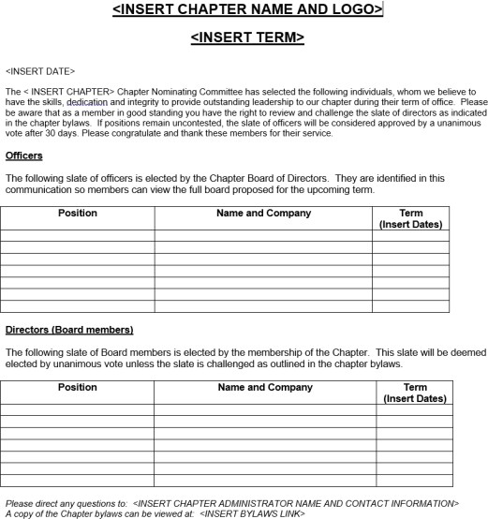

STEP 2

Complete Document 2 - Chapter Slate for Internal Distribution

- In the same toolkit, locate template labeled “Chapter Slate for Internal Distribution” in the toolkit. This is an excel document. (Best practice – close all other excel documents before opening).

- Complete “Chapter Slate for Internal Distribution” template with your new slate of individuals, nominated for incoming Board of Directors as follows:

  - Click “ENABLE EDITING”
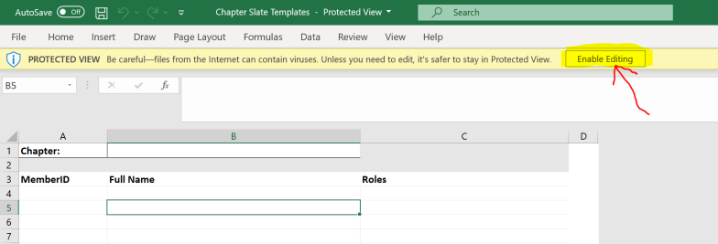

  - Click into cell 1B to activate drop-down arrow:
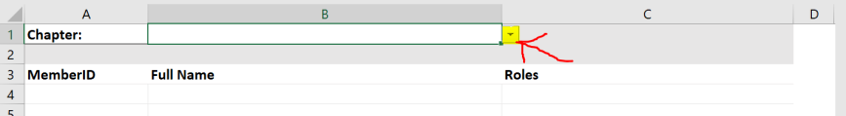

  - Column B – click “drop-down arrow” to see Chapters’ list, then select your Chapter name:
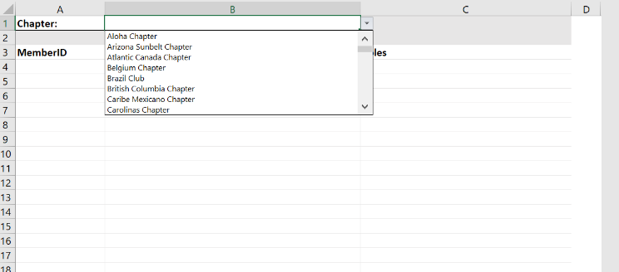

ENTER THE FOLLOWING INFORMATION:
    - Column A – Role
Select the role from the list of titles that applies most effectively to the role of your board member.
  - The drop-down list is developed from ALL position titles used historically year over year. New roles will not be created.

  - Column B – Member ID

  - Column C and D – First Name and Last Name

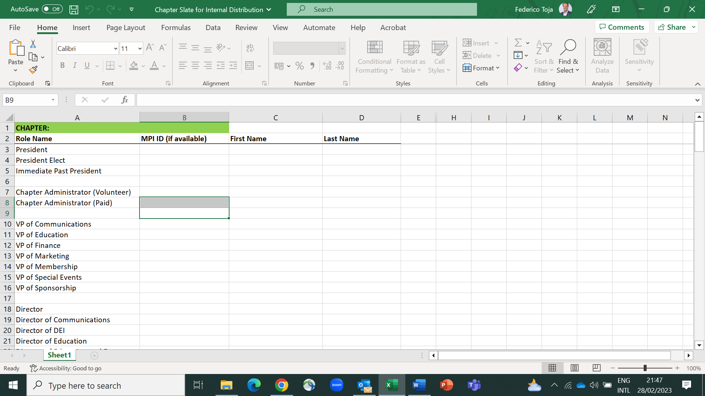

- This is a LIVE document. When you have completed entering your slate you must save the document.

- TO SAVE: click “File” on the top left corner:
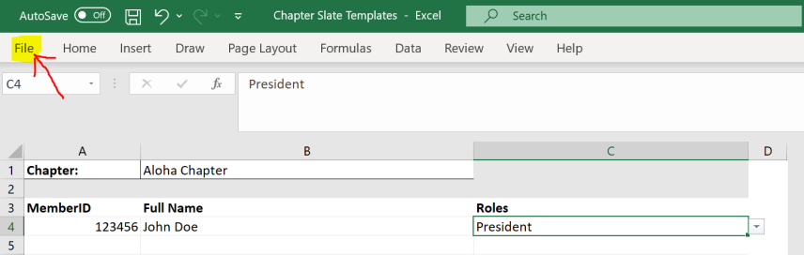

- From drop-down menu Click “Save As” name your document:

“<INSERT CHAPTER NAME> <INSERT FISCAL YEAR> Chapter Board Slate for Internal Distribution”
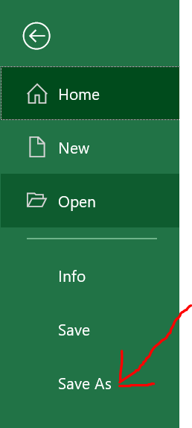

- Send email to your Chapter Operations Manager with your excel document attached. “<INSERT CHAPTER NAME> <INSERT FISCAL YEAR> Chapter Board Slate for Internal Distribution”

- Also attach to your email the previously saved word document 1: “Form 1 – Chapter Board Slate for Membership Distribution”.

SPECIAL NOTE - IF YOU HAVE ANY CHANGES AFTER FINAL SUBMISSION OR ADDITIONS OR CHANGES LATER IN THE YEAR – PLEASE NOTIFY YOUR COM VIA EMAIL.

