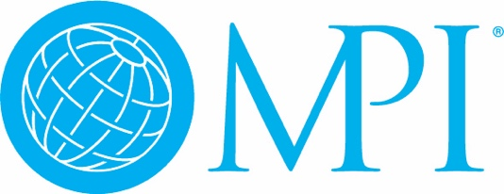

**FY2025 Regional Council Chapter/Club Representative Due December 1**

Your Chapter/Club’s appointment of the FY2025 Regional Council Representative is due no later than December 1.

This appointment requires a vote of the current Board of Directors. It is recommended that the representative be a member of the FY2025 Board of Directors, however, it is not a requirement.

Once finalized, please submit your representative using [this form](https://nam04.safelinks.protection.outlook.com/?url=https%3A%2F%2Fapp.smartsheet.com%2Fb%2Fform%2F8ab1de0c916d4a2db4eb62450948a5c0&data=05%7C02%7Calayton%40mpi.org%7Cb30fcd4f21fc466644f708dce15b2b41%7Cce03356c699048efbcf5929c8f32f15a%7C0%7C0%7C638633028920462506%7CUnknown%7CTWFpbGZsb3d8eyJWIjoiMC4wLjAwMDAiLCJQIjoiV2luMzIiLCJBTiI6Ik1haWwiLCJXVCI6Mn0%3D%7C0%7C%7C%7C&sdata=dWtAnLOPT8tXFsRjvbE0DzKTGCkQqRw51t8Yyweo%2BLw%3D&reserved=0).