READING THE CHAPTER DASHBOARD
Monthly Statistics
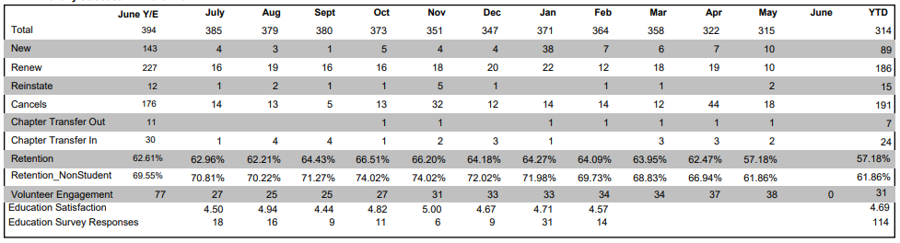
Most of the information contained in this section is automatically populated by MPI Global. The YTD membership data is live when the report is generated – the monthly data is generated on the last day of each month).
The first column of data reflects the year end totals from the previous fiscal year. Please note the data in the current month may not align with the Year To Date (YTD) total in the final column. This is a result of the live data. While in May the chapter had 315 members, when this report was generated, the total is 314 YTD (they lost one member from the time the May numbers were posted to the date of the current report). The membership statistics in this chart reflect ALL members including students.
Only the three items at the bottom of the chart are entered by the chapter: Volunteer Engagement, Education Satisfaction and Education survey Responses:
Volunteers Engagement: the total number of volunteers the chapter had for the month being reported. This includes engaged board members, committee chairs, committee volunteers, task force volunteers, special projects volunteers (volunteers should be counted only once, even if they are involved in multiple committees, projects, etc.)

Education Satisfaction: the total sum of the survey scores for Overall Program Satisfaction for all educational events for the month being reported.
All educational event surveys must include a question that allows attendees to rate their Overall Program Satisfaction using a 5-point rating scale with 1 being the lowest satisfaction and 5 being the highest satisfaction (1 – 5 rating). The only score reported on the dashboard is the overall satisfaction question. Overall program satisfaction scores are to be added: i.e. 4 + 4 + 5 + 4 + 5 + 3 = 25 (the sum of all scores, 25, should be entered).

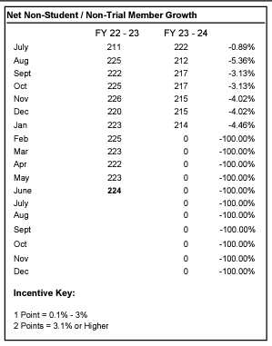
Net Non-Stu/Non-Trial Member Growth Incentive
In this section, the current membership total (excluding students and trial members) is compared against the total from the previous fiscal year end. In the example, the previous year end ed with 224 non-student members. January of Fiscal Year (FY) 23-24 yielded 214 members – a loss of 4.46%.
The bottom of the chart contains the current target goals and YTD eligibility for Metrics points.

Accredited Education Events
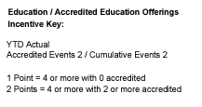
This section notates the number of accredited events the chapter has produced.
The number of accredited events is entered in the dashboard by the chapter. It includes the total number of accredited educational events the chapter had for the month being reported. Accredited educational events are those that provide clock hours/continued education units for participants. These can be in collaboration with another associations (ASAE/CSAE, ILEA, PCMA, etc.), educational organization (city colleges, universities, etc.) or other organizations like the Event Industry Council.
Member Satisfaction
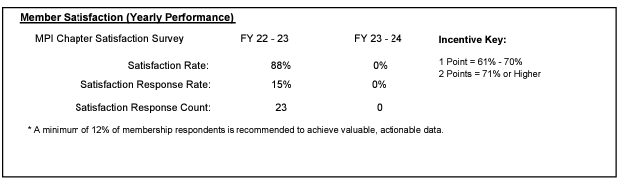
This section reflects the results of the Membership & Chapter Satisfaction Survey conducted annually by MPI Global. It is populated once annually when the survey results are complete. Note that the metric points are based on satisfaction rate based on top-two box scoring (if the scale is 7 points, then only those who select a 6 or 7 out of 7 are counted in the satisfaction rate. While there is a recommended minimum percentage of respondents are recommended, the chapter is not penalized if the respondent rate falls below the recommended rate. For a complete survey report, see the Chapter Metrics section of the Chapter Leadership Resource Page (CLRP).

Chapter Financial Management
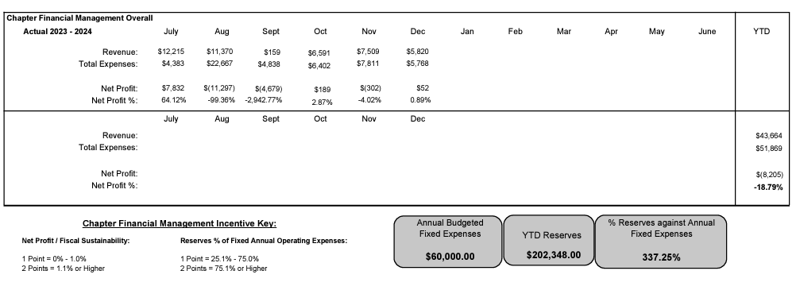
All information in this section is entered by the chapter:
Total Revenue: the total revenue amount for the month reported.

Total Expenses: the total expense amount for the month reported.

Annual Budgeted Fixed Expenses: the amount of annual fixed expenses for the chapter. This should not include any event-related expenses, only expenses needed to keep the chapter operational (i.e., costs related to chapter administrator, bank fees, telecommunication, rent, etc.). This amount should only be updated if there is a change in your annual budgeted fixed expenses.

Year to Date Reserves: the current balance of the reserves amounts (savings and investments only) for the month being reported (reserves balances may fluctuate month-by-month as deposits and/or withdrawals are made). Review the Chapter Policies for recommended reserve thresholds.

Engagement
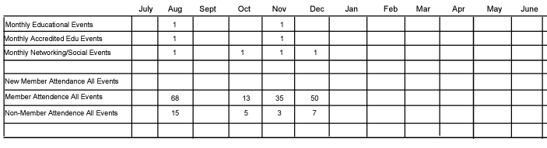
All information in this section is entered by the chapter. This section reflects membership engagement across chapter programs.

Education Events: The total number of educational events (non-accredited) the chapter had for the month.

Accredited Education Events: The total number of accredited educational events the chapter had for the month being reported. Accredited educational events are those that provide clock hours/continued education units for participants. These can be in collaboration with another associations (ASAE/CSAE, ILEA, PCMA, etc.), educational organization (city colleges, universities, etc.) or other organizations like the Event Industry Council.

Networking/Social Events: The total number of networking/social events the chapter had for the month.

Member Attendance All Events: The total number of members that attended all chapter events (educational, accredited, networking and social) for the month.

Non-Member Attendance All Events: The total number of non-members who are part of the meetings/events industry that attended all chapter events (educational, accredited, networking and social) for the month being reported. This should only include industry people who could potentially become a member after attending a chapter event.

Metric Dashboard Notes
This section reflects any notes the Chapter or Regional Operations Manager would like to include about the month’s metrics. It is beneficial to add notes when information entered is an outlier from average months. For example, if event attendance was increased due to a collaborative educational program or if there were no events held in a particular month.

